Facility name: _______________________ Region/District name: ________________  Facility type: _______________________ Facility hours: ______________________ | Facility supervisor:  ___________________  Reviewer:  ___________________  Date: ___________________
New HTN patients registered in prior month (N):____ Avg daily HTN patients seen (N):___
Total HTN patients registered (N) to date:____ Total Catchment population (N):___
Is the HTN treatment protocol displayed for staff to reference? □ Yes □ No
Is the BP measurement protocol displayed on the wall/desk? □ Yes □ No
Hypertension Health Care Facility Checklist (follow-up visits)
1 | BP measurement
1.1 | Number of functional BP devices in the facility (N) |  |  |  |  | Digital: __ Aneroid: __ Mercury: __
1.2 | Observe 3 patient BP measurements (refer to BP checklist below): |  |  |  |  | Circle # out of 3 meeting criteria:
1.2.a | BP measured with patient at rest (sitting quietly) |  |  |  |  | 0 1 2 3
1.2.b | Proper positioning (back support, arm at heart level, feet on ground) |  |  |  |  | 0 1 2 3
1.2.c | Correct cuff size used |  |  |  |  | 0 1 2 3
1.2.d | Exact BP recorded, not rounded (i.e., 142/92 not 140/90) |  |  |  |  | 0 1 2 3
1.2.e | If patient’s initial BP is >140/90, repeat BP measured after 3-5min |  |  |  |  | 0 1 2 3 N/A (N): ___
1.2.f | If patient’s repeat BP is >140/90, refer to medical officer |  |  |  |  | 0 1 2 3 N/A (N): ___
2 | Treatment (based on review of 5 patient records) Circle # out of 5 meeting criteria:
2.1 | Blood pressure measurement is documented |  |  |  |  | 0 1 2 3 4 5
2.2 | Medication (names/doses) are documented |  |  |  |  | 0 1 2 3 4 5
2.3 | If BP>140/90, HTN medication is prescribed/intensified per protocol |  |  |  |  | 0 1 2 3 4 5 N/A (N): ___
2.4 | If HTN medication is prescribed, prescription length is ≥30 days |  |  |  |  | 0 1 2 3 4 5 N/A (N): ___
2.5 | Follow up visit scheduled for the patient |  |  |  |  | 0 1 2 3 4 5
3 | Medication Availability
Drug name*  *Modify names per hypertension protocol |  | Current stock  (number of tablets) | Any stock outs in last 3 months? (Y/N) | Monthly consumption (number of tablets) | Is stock sufficient for next quarter, i.e., current stock > monthly consumption x 3 months? (Y/N) |  | Info not available  (X)
Amlodipine
HCTZ
Lisinopril
Others (specify)______________
4 | Service delivery (interview 3 patients who were prescribed meds) Circle # out of 3 meeting criteria:
4.1 | Did the patient receive all prescribed medications at this visit? |  |  |  |  | 0 1 2 3
4.2 | Does the patient understand how to take his/her medicines? |  |  |  |  | 0 1 2 3
5 | Patient Follow up (consult register or ask staff) |  |  |  |  | Check here if:
5.1 | Total number of overdue* hypertension patients at the facility (N)___ |  |  |  |  | Unable to assess __ No system in place ___
5.2 | Number of overdue* patients who received outreach phone call (N)___ |  |  |  |  | Unable to assess __ No system in place ___
*As per local definition of “overdue”, e.g., no visit in the past 1 month, no visit in the past 3 months, etc.
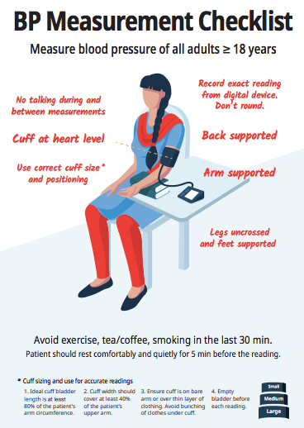

Summary of visit

Indicators | Observations | Recommendations
BP measurement
Treatment
Medication Availability
Service delivery
Patient follow up
Other

